C845 Task 3
Data Security and Systems Defense Artifacts

A. Data Protection Scenario

FinSecure Corp. is a regional financial services organization that manages customer financial transactions, employee records, and compliance documentation. The company operates both on-premises systems and remote or offsite resources. As part of a planned expansion, FinSecure is reviewing its data protection and security operations to confirm alignment with organizational and regulatory requirements.

Current Operations
- The Human Resources (HR) and Finance departments exchange payroll and employee data using an internal FTP server that operates with legacy file-transfer protocols.
- Customer financial data is transmitted from internal applications to third-party partners over HTTPS connections that allow multiple TLS protocol versions, including TLS 1.0.
- Email messages with attached financial reports are sometimes used to share information with external auditors.
- Remote employees connect through a VPN service that supports several TLS versions and is configured for split-tunneling network access.
- System administrators manage virtual machines on internal network links using Remote Desktop Protocol (RDP).

Data Storage Practices
- Daily backups of customer transaction data are written to a shared offsite storage repository accessible by multiple departments.
- The offsite storage environment retains uploaded files in their existing format without server-side or automatic encryption.
- The on-premises Finance server maintains customer PII and financial records in a relational database that stores data in clear text on disk.
- Application encryption keys are stored in configuration files located on the same servers that host the associated applications.
- Endpoint laptops synchronize working files to local directories that use standard file-system encryption settings.
- Archived HR records are kept in a document management system that applies password protection to compressed archives.

Key Management and Policy Overview
- Encryption keys are generated within individual applications and maintained by their respective system owners.
- Some systems use self-signed certificates that are renewed manually as part of routine maintenance.
- The organization’s encryption policy is reviewed and updated according to internal governance schedules.

B. System Architecture Diagram (Simplified)
The following diagram illustrates FinSecure Corp.’s current distributed network environment. The data center hosts core business systems, including application, web, and database servers, connected through a single network gateway. The corporate network provides user access from HR and IT subnets. Remote employees connect through a VPN gateway that links the corporate site to the data center via an IPSec connection. Network traffic is routed through a perimeter firewall and internal switch before reaching departmental subnets.

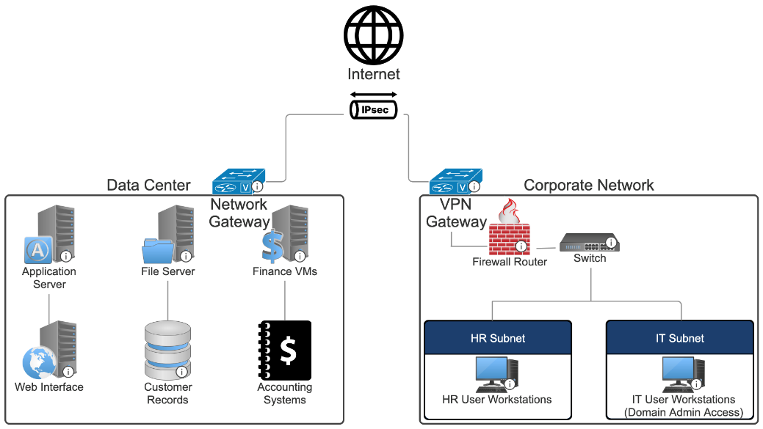

C. Operational Environment Summary
The following describes how FinSecure currently monitors systems, maintains operations, and manages data protection and recovery.

Monitoring and Detection
- System, application, and network logs are stored on the devices where they are generated and retained for 30 days.
- Firewall and VPN activity reports are reviewed by IT staff on a weekly schedule during maintenance windows.
- Endpoints run antivirus software that generates local alerts but do not forward those alerts to a central console.
- Security events are documented and handled by IT administrators as part of their normal workload.

Incident Response and Access Controls
- IT staff coordinate incident response when issues are reported through the internal help desk system.
- Remote and administrative users sign in with usernames and passwords.
- Password changes occur annually as part of the credential management process.
- Access reviews are performed at the manager’s request.

System Maintenance and Patching
- Operating system and application updates are deployed on a quarterly cycle after testing in the staging environment.
- Updates are installed manually by IT administrators.
- Verification is recorded in the change-tracking spreadsheet once maintenance is complete.

Backup and Recovery
- Nightly data backups are stored in an offsite storage repository managed by IT.
- Backup files are retained for 90 days and use standard storage permissions.
- A full restoration test is completed once each year to verify recoverability.
- IT staff review backup reports the morning after each run.

Change and Configuration Management
- System modifications are documented by IT team members in a shared spreadsheet.
- Configuration details for virtual machines and offsite resources are updated when changes occur.
- Certificates are renewed manually during maintenance windows.

